**Green Society Public School**

**D-09**

**Ratnanagar-7, Sauraha, Chitwan**

**Second Terminal Examination-2082**

**Class: Nursery Time: - 2 hrs. F.M.: 50**

**Sub: English (O)**

1. How are you?
2. What is your name? [5]
3. In which class do you read? [5]
4. What is your class teacher’s name? [5]
5. What is your father’s name? [5]
6. What is your favorite fruit? [5]
7. Read the given letters. [10]

Ff Gg Hh Ii Jj

Kk Ll Mm Nn Oo

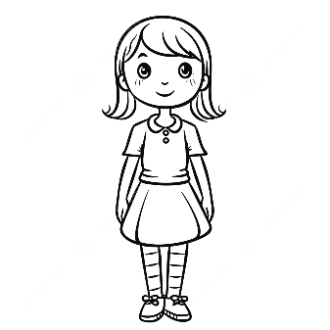 8 . Identify the pictures. [5]

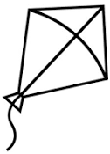

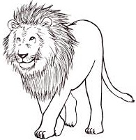



1. Neat and clean. [10]

**The End**